**GlobalSight Upgrade Installer Instructions (for Windows & Ubuntu)**

**For Windows:**

**Before running the GlobalSight Upgrade Installer, make sure that**

* GlobalSight service is stopped;
* MySQL database is started;
* Oracle JDK 8 (jdk 1.8.0 update 45) is installed.

1. Download and unzip the **GlobalSight_Upgrade_Installer_*<version>*.zip** package.

2. Edit file **config.properties** to set GlobalSight installation directory and configure certificate information to sign jars.

3. Double click on the batch file **run.bat** to launch the installer.

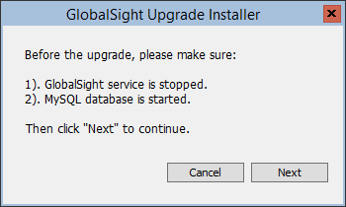

4. Click **Next** button to continue.

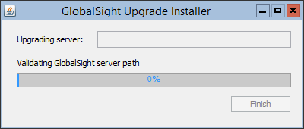

5. If the GlobalSight installation directory is not set in step 2, you will be prompted to specify the GlobalSight installation directory.

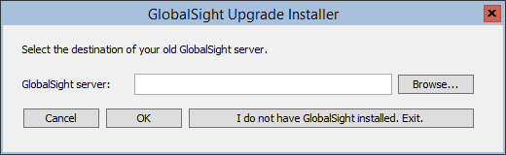

Click **Browse** button to choose GlobalSight installation directory, and then click **OK** button to continue.

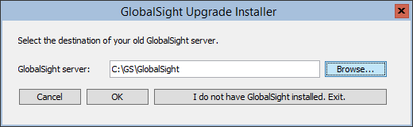

6. Update GloablSight configuration file to point to Oracle JDK 8 home directory.

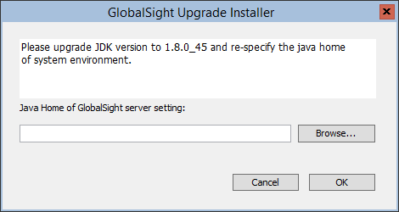

Click **Browse** button to choose Oracle JDK 8 installation directory, and then click **OK** button to continue.

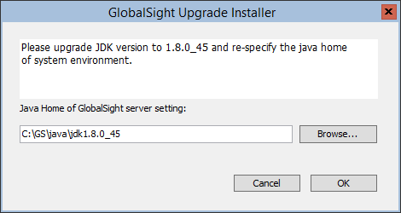

7. When upgrade complete, click **Finish** button to exit the installer.

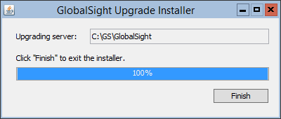

The GlobalSight Upgrade Installer will back up previous version of GlobalSight and apply upgrade to GlobalSight.

The previous GlobalSight files are stored in <GlobalSight_Upgrade_Installer_x.x.x.x>/installer/backup directory.

The upgrade log file log.txt can be found in

<GlobalSight_Upgrade_Installer_x.x.x.x>/installer directory.

8. Restart GlobalSight service.

**For Ubuntu:**

**Before doing the GlobalSight upgrade:**

a. Log into as a user with sudo privilege.

b. Stop Globalsight service:

Type: **sudo** **/etc/init.d/globalsight stop** or **sudo** **service globalsight stop**

c. Make sure MySQL database is running.

d. Make sure Oracle JDK 8 (JDK1.8.0 update 45) is installed.

1. Download and unjar the GlobalSight_Upgrade_Installer_<version>.zip package.

Type**: jar xvf GlobalSight_Upgrade_Installer_*<version>*.zip**

2. Add executable attribute for run.sh script file.

Type: **chmod u+x run.sh**

3. Edit file **config.properties** to set GlobalSight installation directory and configure certificate information to sign jars.

4. Run the GlobalSight Upgrade Installer.

Type: **sudo PATH=$PATH:$JAVA_HOME/bin ./run.sh**

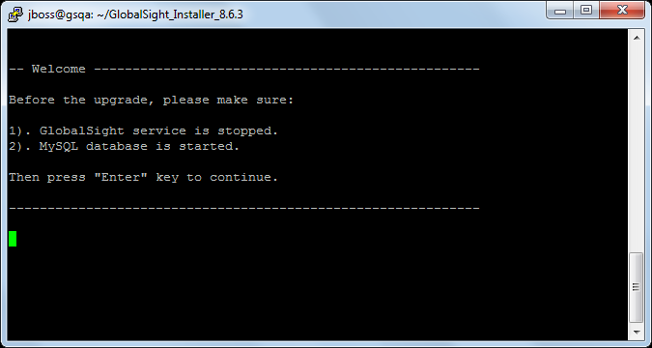

5. If the GlobalSight installation directory is not set in step 3, you will be prompted to manually enter the directory when you press **Enter** key to continue.

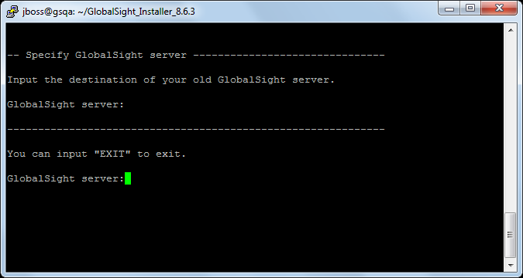

Enter GlobalSight installation directory and press **Enter** key to continue.

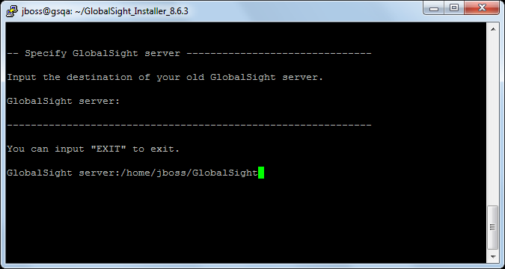

6. Update GloablSight configuration file to point to Oracle JDK 8 home directory.

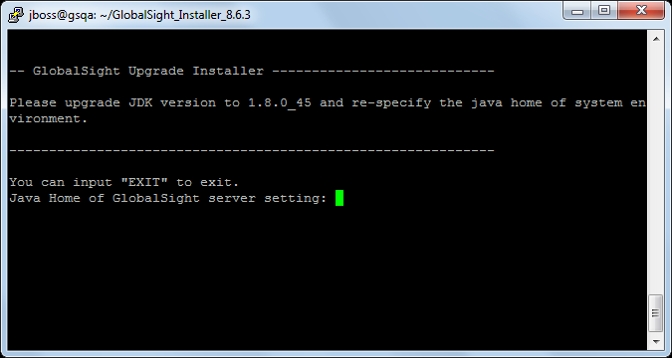

Enter Oracle JDK 8 installation directory and press **Enter** key to continue.

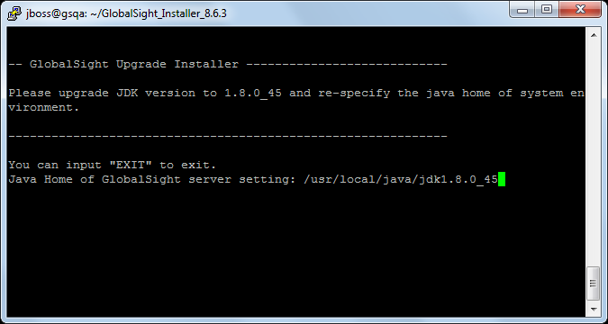

7. When upgrade complete, press **Enter** key to exit the installer.

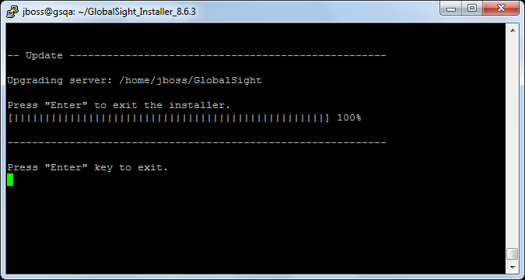

The GlobalSight Upgrade Installer will back up previous version of GlobalSight and apply upgrade to GlobalSight.

The previous GlobalSight files are stored in <GlobalSight_Upgrade_Installer_x.x.x.x>/installer/backup directory.

The upgrade log file log.txt can be found in

<GlobalSight_Upgrade_Installer_x.x.x.x>/installer directory.

8. Change the ownership of current GlobalSight instance.

Type: **sudo** **chown -R jboss:jboss /path/to/GlobalSight/ installation/directory**

9. Add executable attribute for standalone.sh and jboss-cli.sh script files.

Type: **sudo chmod u+x <GlobalSight installation directory>/jboss/server/bin/standalone.sh**

Type: **sudo chmod u+x <GlobalSight installation directory>/jboss/server/bin/jboss-cli.sh**

10. Restart GlobalSight service:

Type: **sudo** **/etc/init.d/globalsight start** or **sudo** **service globalsight start**